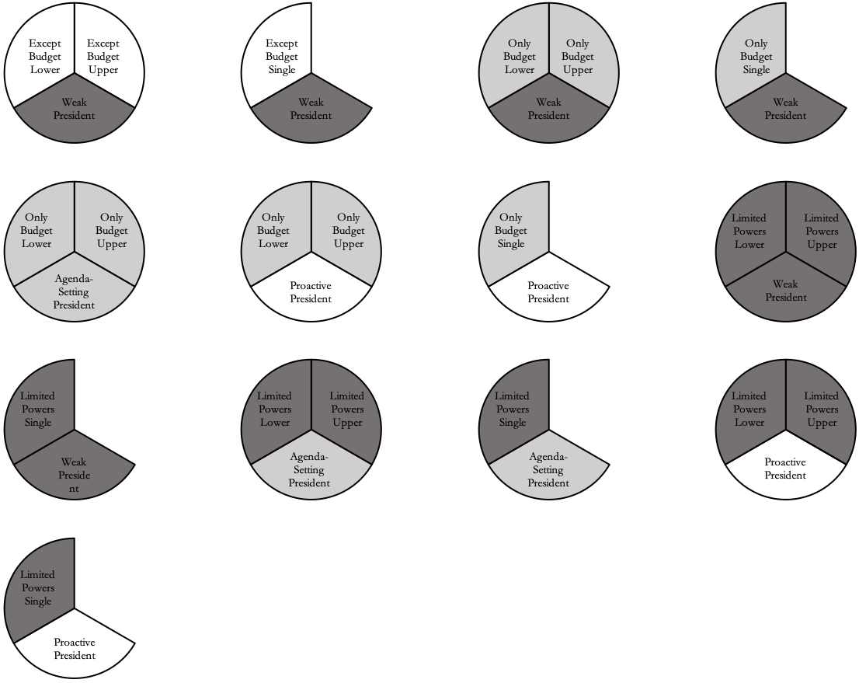

Process One

3 Cases

Process Two

2 Cases

Process Three

3 Cases

Process Four

3 Cases